# Module 1 Written Report

* *Given the provided data, what are three conclusions that we can draw about crowdfunding campaigns?*
  + Theatre crowdfunding campaigns are the most popular.
  + Successful campaigns tend to start in the early summer (Jun, Jul).
  + August is the worst month to start a campaign because:
    - The lowest number of successful campaigns start in August.
    - A high number of failed campaigns also start in August.
* *What are some limitations of this dataset?*
  + The length of the campaigns are not factored in. This may or may not have an unseen effect on the success of the campaign, but we are unable to determine since the dataset does not look for it.
* *What are some other possible tables and/or graphs that we could create, and what additional value would they provide?*
  + A pie chart may be used to better visualise the proportion of campaigns that belong to certain categories/subcategories. E.g.
  + 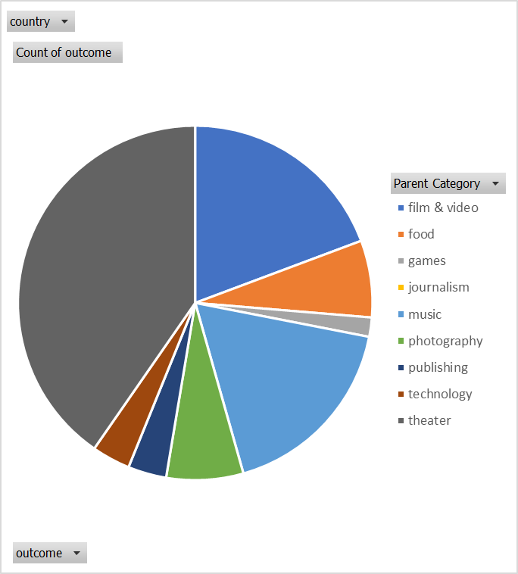

## Statistical Analysis

* *Use your data to determine whether the mean or the median better summarizes the data.*
  + As the data is heavily skewed to the right (mean>median), the median would be better than the mean for summarising central tendancy.
* *Use your data to determine if there is more variability with successful or unsuccessful campaigns. Does this make sense? Why or why not?*
  + There is more variability within successful campaigns, as both variance and stdev for backer count are higher. This makes sense, as there are far more successful campaigns than unsuccessful ones.